**Introduction**

Web pages made with HTML and CSS display static content. They don't respond to user actions like clicking a mouse or typing a key.

JavaScript and jQuery are used to make web pages interactive.

* JavaScript is a programming language used to create web pages that change in response to user actions.
* jQuery is a collection of prewritten JavaScript code that lets us easily create interactive effects on our site.
* 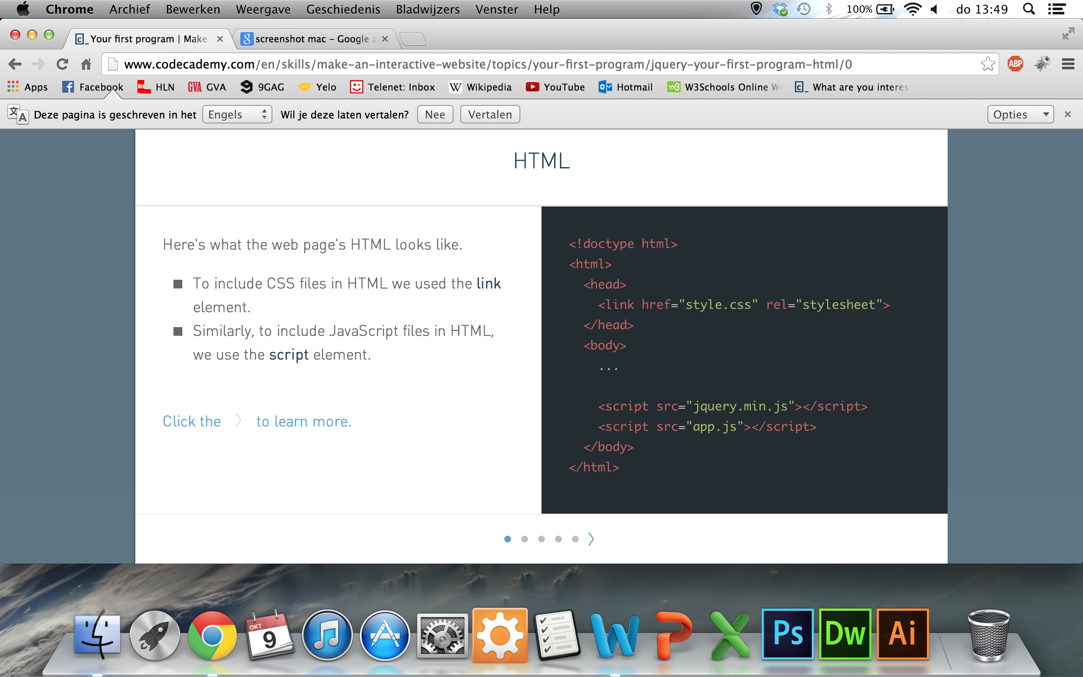

### HTML

Here's what the web page's HTML looks like.

* To include CSS files in HTML we used the **link**element.
* Similarly, to include JavaScript files in HTML, we use the **script** element.

To include CSS files in HTML, we use the linkelement. The link element tells the browser where to find a CSS file.

Similarly, to include JavaScript files in HTML, we use the script element.

The script element tells the browser where to find a JavaScript file. It has an attribute inside the opening<script> tag named src, which has the address of the JavaScript file.

The first script loads in jQuery.

The second script loads in app.js. This is where the code for the dropdown menu program lives.